Sai Anirudh Kadambari (SXK210128), Akshay Kamoji (AMK210012), Rashmi Reddy Kommidi (RXK210050), Bhargava Venkat Lukka (BXL210005), Shivam Mahendrakumar (SXM177231), Dileep Reddy Puttareddy (DXP210038), Ishujeet Singh (IXS210014), and Phillip Turner (PMT190000)

BUAN 6312.001

Applied Econometrics and Time Series Analysis

Group Project Final Paper

Group 5

**Introduction**

With the continued rise of mass shootings in the United States, gun violence and gun laws are a major topic. One side argues that people need to be able to defend themselves with guns from crimes or potential mass shootings while the other side argues for more gun control and less guns on the streets to decrease gun violence.

Many states have passed laws to allow more citizens to carry guns via concealed-carry permits. The name of these right-to-carry (RTC) laws is shall-issue laws which means that the issuing authority is compelled to issue a permit if applicants are an adult, have no major criminal record, no mental illness issues, and complete a gun safety course (if required by the state). Beyond that, there are no other requirements, and the states must grant the right-to-carry permit.

The main research question here is whether these shall-issue laws (expanding the number of guns in citizen’s hands) reduces crime or has no impact:  
  
H0: Shall-issue gun laws have no effect on the crime rate of a city

Ha: Shall-issue gun laws have a negative (diminishing) effect on the crime rate of a city

**Literature Review**

The existing literature work of “Right-to-Carry Laws and Violent Crime: A Comprehensive Assessment Using Panel Data and a State-Level Synthetic Control Analysis” by John J. Donohue, Abhay Aneja, and Kyle D. Weber focuses on very advanced statistical methods to determine the impact on violent crime when states adopt right-to-carry (RTC) concealed handgun laws.

This paper determined that RTC laws are associated with 13-15 percent higher aggregate violent crime rates ten years after adoption and that the average RTC state would need to roughly double its prison population to offset the increase in violent crime caused by the RTC adoption.

We aim to apply basic statistical analysis and modeling to uncover any interesting trends, inferences, and insights to research further.

**Data**

Guns is a balanced panel of data on 50 US states, plus the District of Columbia (for a total of 51 “states”), by year for 1977 – 1999. Each observation is a given state in a given year. There are a total of 51 states × 23 years = 1,173 observations. This data was provided by Professor John Donohue of Stanford University and was used in his paper with Ian Ayres “Shooting Down the ‘More Guns Less Crime’ Hypothesis” Stanford Law Review, 2003, Vol. 55, 1193-1312.  
  
Link to Dataset: <https://www.princeton.edu/~mwatson/Stock-Watson_3u/Students/Stock-Watson-EmpiricalExercises-DataSets.htm>

|  |  |
| --- | --- |
| **Variable** | **Definition** |
| *vio* | violent crime rate (incidents per 100,000 members of the population) |
| *rob* | robbery rate (incidents per 100,000) |
| *mur* | murder rate (incidents per 100,000) |
| *shall* | = 1 if the state has a shall-carry law in effect in that year  = 0 otherwise |
| *incarc_rate* | incarceration rate in the state in the previous year (sentenced  prisoners per 100,000 residents; value for the previous year) |
| *density* | population per square mile of land area, divided by 1000 |
| *avginc* | real per capita personal income in the state, in thousands of dollars |
| *pop* | state population, in millions of people |
| *pm1029* | percent of state population that is male, ages 10 to 29 |
| *pw1064* | percent of state population that is white, ages 10 to 64 |
| *pb1064* | percent of state population that is black, ages 10 to 64 |
| *stateid* | ID number of states (Alabama = 1, Alaska = 2, etc.) |
| *year* | Year (1977-1999) |

**Exploratory Data Analysis**

*Shall Law Trends*

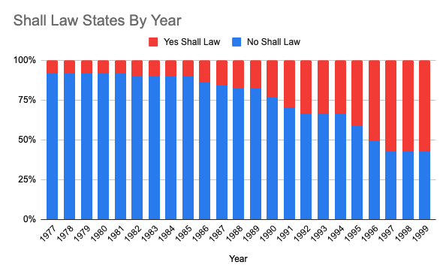

Initially looking at the number of states with Shall Laws uncovered that only 4 states in 1977 had approved Shall Laws, representing 8% of states. By 1999, 57% of states (29 total states) had approved Shall Laws indicating that these states believed that society and crime would improve with this legislation.

*Crime & Incarceration Rate Trends*

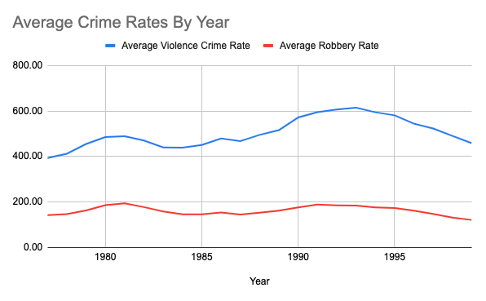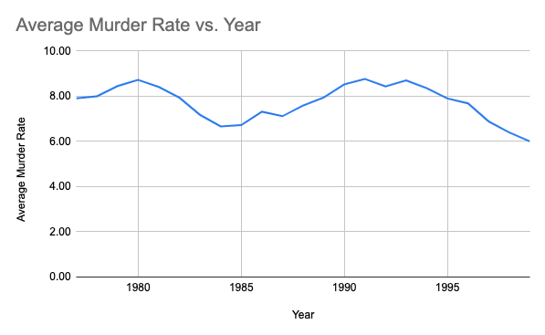

Overall, the Average Violence Crime Rate peaked around 1981 and then decreased before increasing again in 1993 and decreasing until 1999. Obviously, many variables are involved in the Violence Crime Rate but analyzing these changes could be interesting. While the Violence Crime Rate is the target dependent variable, the Average Robbery Rate and Murder Rate have similar trends when looking at the metrics by year suggesting a correlation between all types of crime.

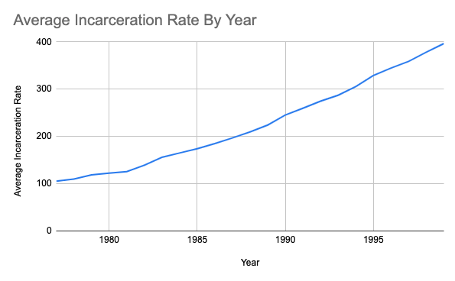

At the same time, the Average Incarceration Rate has been steadily increasing since 1980 to an all-time high in 1999 showing that more criminals are being locked up and perhaps having an impact on the decreasing Average Violence Rate.

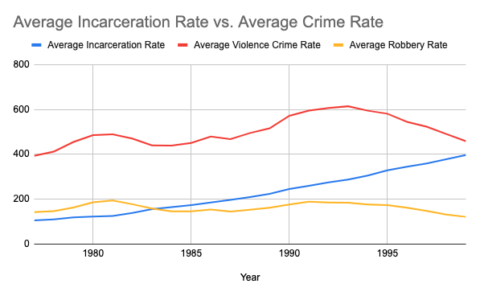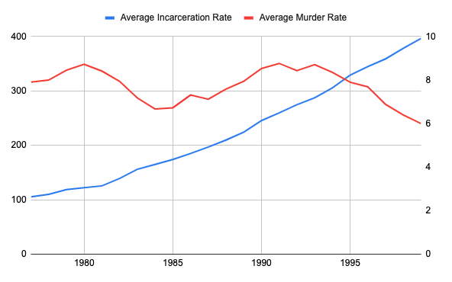

The Incarceration Rate seems to show a potential correlation in the decreasing crime rates in the late 1990s, suggesting that Incarceration Rate is a key independent variable.

*Race Population Trends*

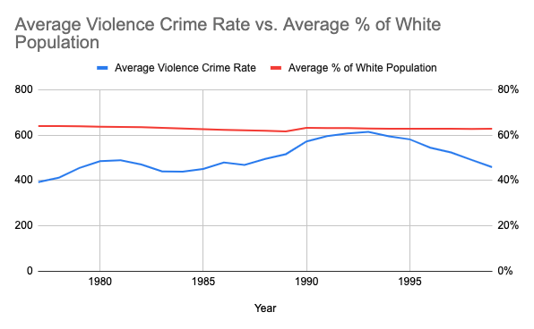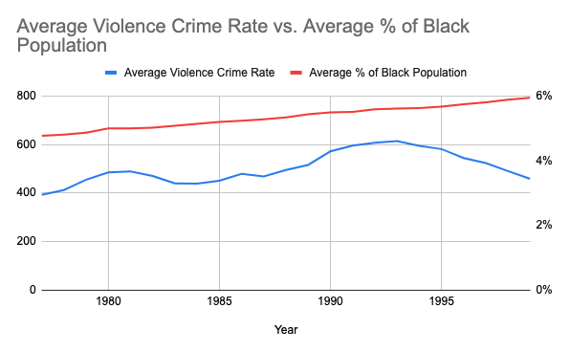

From a population race breakout, the Average Percentage of White People has remained relatively level while the Average Percentage of Black People has slowly increased over the last 20 years. As noted in other studies, race and crime are major, complex societal issues.

*Income Trends*

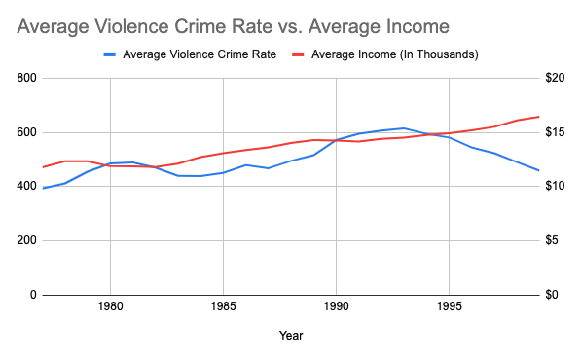

While Incarceration Rate increased steadily over the years, the Average Income also increased which could be contributing to the lower Average Violence Crime Rate.

*Correlation Heatmap*

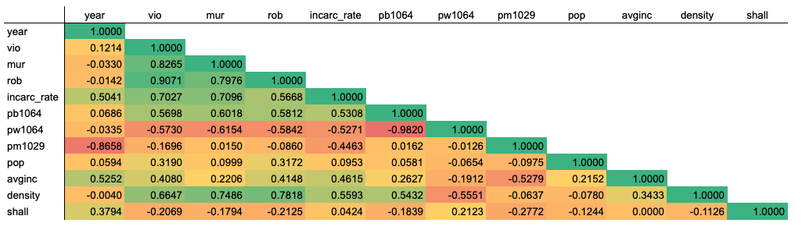

Not surprisingly, all crime rates have a high correlation with each other suggesting that more crime of one type contribute to crimes of all types. Another interesting note is that Population Density shows a positive correlation with Violence Crime Rate which makes sense in that generally cities have higher crime rates that rural areas. Lastly, the Shall Law shows a negative impact to Violence Crime Rate which is different than the published literature.

*Shall Law Impact – Pre/Post*

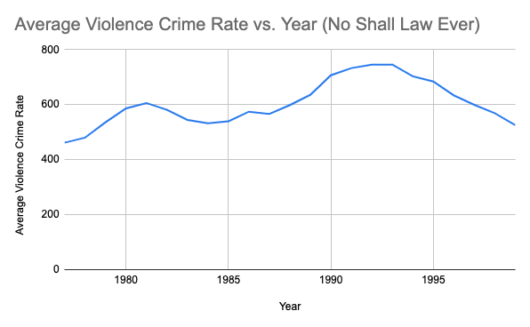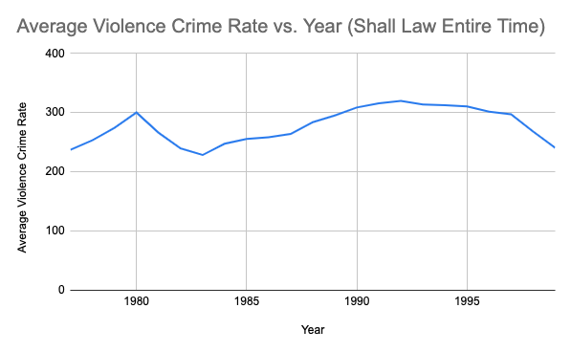

Looking at the above graphs for states with no shall laws ever and states with shall laws the entire time, both groups of states have similar Average Violence Crime Rate trends. Overall, the states with shall laws appear to have lower crime rates across all time periods.

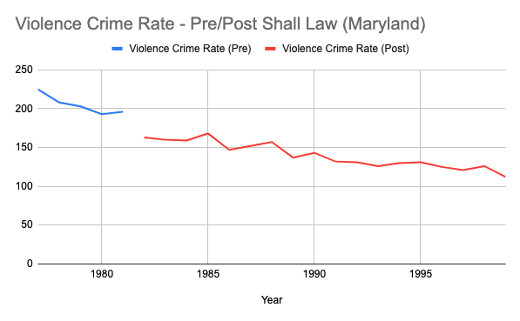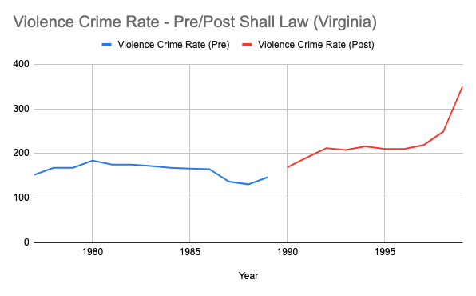

Looking at individual states, some states experience increases in Violence Crime Rate after issuing Shall Laws while some states see decreases in Violence Crime Rate and others seem to just follow the overall trend in Violence Crime Rate.

**Data Pre-Processing**

*Distribution of Population Observations*

Except for avginc (average income) and shall (The dummy variable for shall carry law), all other variables have been transformed so that they can be normally distributed.

*Multicollinearity Check  
  
*

Population will not be considered for regression as it shows high collinearity with Density and the variables that represent the proportion of White and Black populations, lpb1064 and lpw1029, are highly correlated. Hence, lpw1029 will not be used for regression.

Corr(lpop, lpb1064) = 0.510  
Corr(lpop, lpw1029) = -0.430  
Corr(lpop, ldensity) = 0.876  
Corr(lpb1064, lpw1029) = 0.870

**Empirical Method – Pooled OLS**

*Model1*

We first used a pooled OLS model and regressed the coefficient directly.

The general form of a fixed effects regression model is as follows:  
  
                             Yit=β0+β1X1,it+β2X2,it+γ2D2i+γ3D3i+⋯+γnDni+uit   
where:  
  
X1,X2 = Variables that are time dependent  
γ = Dummy variable coefficient for each entity which captures heterogeneity  
uit  = Idiosyncratic error Term

**Results**

*Pooled OLS Regression I – Violence Rate*

Violence rate was regressed with incarceration rate, shall, density, average income, and percent of Black population in each city.​

The following equation was obtained:

lvio = .057*l_incarcerate-0.0655*shall + 0.040*ldense2 + 0.047*avginc + 0.241*lpb1064_2 + 4.04 + V  
  
where V = β1*stateid1+β2*stateid2+...+βn*stateidn

It can be interpreted as per this equation that if a Shall Carry Law is passed, then, on average, it results in a drop-in violence rate by 6.5%.

The  t-value for Shall is –2.93 which is significant at a 95% confidence interval.

*Pooled OLS Regression II – Robbery Rate*

Robbery rate was regressed with incarceration rate, shall, density, average income, and percent of Black population in each city.​

The following equation was obtained:

lrob = -0.21*l_incarcerate - 0.074*shall + 0.044*ldense2 + 0.078*avginc + 0.28*lpb1064_2 + 3.5 + V  
  
where V = β1*stateid1+β2*stateid2+...+βn*stateidn

It can be interpreted as per this equation that if a Shall Carry Law is passed, then, on average, it results in a drop in robbery rate by 7.85%

The t-value for shall is –2.48 which is significant at a 95% confidence interval.

*Pooled OLS Regression III – Murder Rate*

Murder rate was regressed with incarceration rate, shall, density, average income, and percent of Black population in each city.​

The following equation was obtained:

lmur = -0.24*l_incarcerate - 0.0001*shall + 0.047*ldense2 + 0.017*avginc + 0.034*lpb1064_2 + 3.07 + V  
  
where V = β1*stateid1+β2*stateid2+...+βn*stateidn  
  
It can be interpreted as per this equation that if a Shall Carry Law is passed, then, on average, it results in a drop in murder rate by .01%, which really is not much.

The t-value for shall is –0.01 which is not significant at a 95% confidence interval.

*Insights (Pooled OLS Regression)*

Shall carry laws have a negative effect on robbery and violence rates. Robbers would be more hesitant to commit a crime because of the knowledge that the other person could have a gun.

As per the Regression Equation, shall carry laws have a negligible effect on murder rate. Possible reasons for this could be mass shootings and weak gun control laws.

Other factors such as incarceration rate have a higher effect on both murder rate and robbery rate, which is also significant at a 95% confidence interval. This means that law enforcement agencies who are more effective in maintaining law and order, conducting more investigations, and arresting the right people could reduce the murder rate.

Average income seems to be associated with an increase in crime rate. However, logically, crime should decrease with income. Average income can also increase if income inequality gets larger. There is a strong possibility that an increase in income inequality is associated with an increase in crime.

**Empirical Method – Fixed Effects**

Since a Pooled OLS Model cannot capture the heterogeneity of different samples, we used a fixed effects model.

The general form of a fixed effects model is as follows:

Yit=β0+β1X1,it+β2X2,it+γ2D2i+γ3D3i+ αi ⋯+uit

where:  
X1, X2 = Variables that are time-dependent  
γ = Dummy variable coefficient for each entity which captures the heterogeneity  
uit  = Idiosyncratic error Term

αi  = Fixed effects term.

A demeaned within-groups regression was done on the data and hence the αi (fixed effects) term was eliminated.

**Results**

*Fixed effects Regression - I – Violence Rate*

The following equation was obtained after regressing violence rate:

lvio = -0.068*shall + 0.73*l_incarcerate – 0.069* (l_incarcerate)2 – 0.191*lpb1064 + 0.355* (lpb1064)2 + 0.434*avginc – 0.014* (avginc)2 + 0.33*ldensity + 0.07*(ldensity)2+0.733

From the beta coefficient, it can be interpreted that shall carry laws lower the violence by 6.8%. This variable is also significant.

*Fixed effects Regression - II – Murder Rate*

The following equation was obtained after regressing murder rate

lmur = -0.0288*shall + 0.741*l_incarcerate – 0.039* (l_incarcerate)2 – 0.222*lpb1064 + 0.20* (lpb1064)2 + 0.156*avginc – 0.004* (avginc)2 -0.72*ldensity + 0.056*(ldensity)2 – 2.33

As per this equation, shall carry laws do lower the murder rate by 2.8%. However, the variable isn’t significant at t value of -1.19. More data is required to understand the true relationship between murder rate and shall carry laws

*Fixed effects Regression - III – Robbery Rate*

The following equation was obtained after regressing robbery rate

lmur = -0.043*shall + 0.89*l_incarcerate – 0.0991* (l_incarcerate)2 – 0.625*lpb1064 + 0.392* (lpb1064)2 + 0.43*avginc – 0.0151* (avginc)2 +1.81*ldensity + 0.22*(ldensity)2 – 2.38

As per this equation, shall carry laws lower the murder rate by 4.3%. However, this variable isn’t statistically significant at t value of -1.88. More data is required to understand the true relationship between robbery rate and shall carry laws

**Conclusion**

More data is needed to understand the true relationship between shall carry laws, murder rate, and robbery rate since the variable was not significant. However, it’s clear that shall-carry laws do lower the violence rate.

The idea behind shall carry laws is so that the public can protect itself from criminals who use guns to their advantage.

Since guns lower violence rate, Shall Carry Laws should not be banned. However, strict measures should be taken while issuing guns to the public, such as thorough scanning of the individuals buying them. It has been seen that most people involved in mass shootings are those who have a mental illness or have had a history of mental illness.

Another measure such as linking SSN with gun-license is also a commendable effort.

Also, strict measures should be taken to see to it that guns are not issued to minors.

Public places and public transportation should have a better security and screening processes.

Overall, there is a significant opportunity to improve gun control through additional measures and further research the impact of these measures while also looking at improving security at higher-risk places.